Laporan Basis Data - Part 5

Materi: Pengenalan GROUP BY
1. GROUP BY dasar
SELECT status FROM orders GROUP BY status;
2. Perbandingan dengan DISTINCT
SELECT DISTINCT status FROM orders;
3. GROUP BY dengan Aggregate Function
SELECT status, COUNT(*) FROM orders GROUP BY status;
SELECT orderNumber, SUM(quantityOrdered * priceEach) AS total
FROM orderdetails GROUP BY orderNumber;
4. Syntax CASE...WHEN...
SELECT ColumnName1, ColumnName2,
CASE
WHEN condition1 THEN result1
WHEN condition2 THEN result2
WHEN conditionN THEN resultN
ELSE result
END as alias
FROM TableName;

Quiz 1
SELECT orderNumber, SUM(quantityOrdered * priceEach) AS total,
CASE
WHEN SUM(quantityOrdered * priceEach) >= 50000 THEN 'Target Achieved'
WHEN SUM(quantityOrdered * priceEach) <= 20000 THEN 'Less performed'
ELSE 'Follow Up'
END as remark
FROM orderdetails
GROUP BY orderNumber;
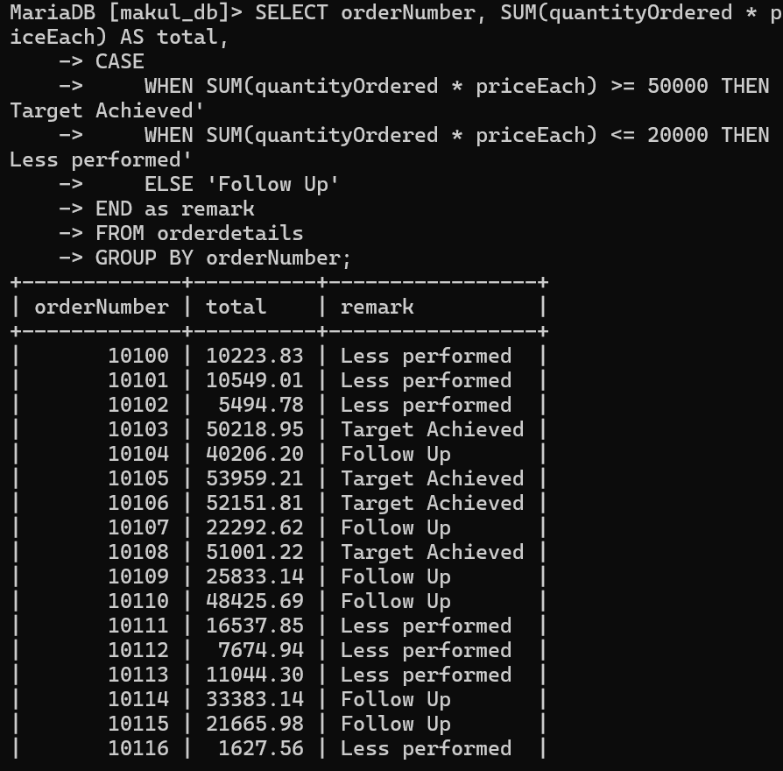

Quiz 2
1. Total seluruh penjualan (revenue)
SELECT SUM(qty * harga) AS total_revenue FROM ms_transaksi;
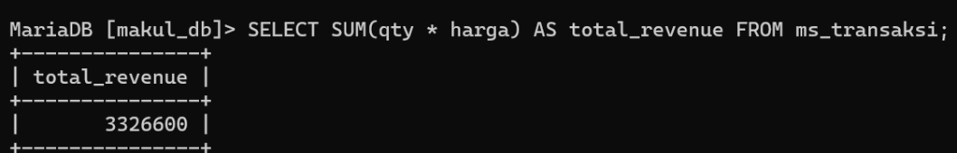
2. Total quantity seluruh produk terjual
SELECT SUM(qty) AS total_qty FROM ms_transaksi;
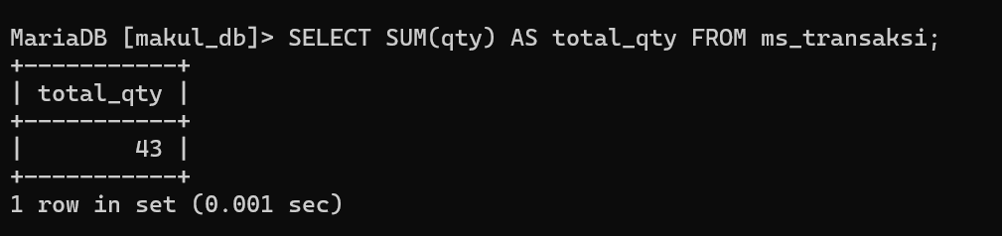
3. Total quantity dan revenue per kode produk
SELECT kode_produk, SUM(qty) AS total_qty, SUM(qty*harga) AS total_revenue
FROM ms_transaksi
GROUP BY kode_produk;
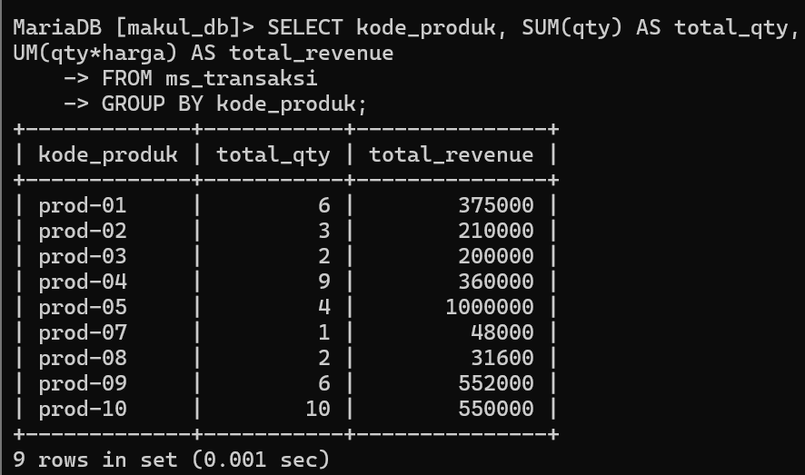
4. Rata-rata total belanja per kode pelanggan
SELECT kode_pelanggan, AVG(qty*harga) AS rata_rata_belanja
FROM ms_transaksi
GROUP BY kode_pelanggan;
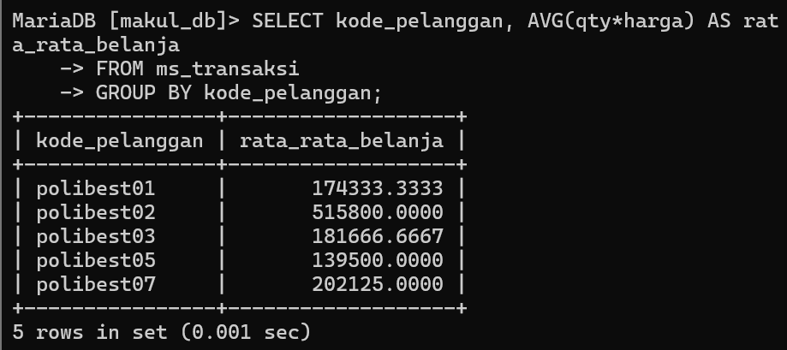
5. Kategori total belanja per pelanggan
SELECT kode_pelanggan, SUM(qty*harga) AS total_revenue,
CASE
WHEN SUM(qty*harga) > 300000 THEN 'High'
WHEN SUM(qty*harga) BETWEEN 100000 AND 300000 THEN 'Medium'
ELSE 'Low'
END as kategori
FROM ms_transaksi
GROUP BY kode_pelanggan;
